FML assignment 1

shiva gadila

2023-01-29

library(tinytex)

#1. Downloaded the Dataset from Kaggle.

#2. IMPORTING THE DATASET:

Hotel.Reservations <- read.csv("~/Desktop/Hotel Reservations.csv")  
head(Hotel.Reservations)

## Booking_ID no_of_adults no_of_children no_of_weekend_nights no_of_week_nights  
## 1 INN00001 2 0 1 2  
## 2 INN00002 2 0 2 3  
## 3 INN00003 1 0 2 1  
## 4 INN00004 2 0 0 2  
## 5 INN00005 2 0 1 1  
## 6 INN00006 2 0 0 2  
## type_of_meal_plan required_car_parking_space room_type_reserved lead_time  
## 1 Meal Plan 1 0 Room_Type 1 224  
## 2 Not Selected 0 Room_Type 1 5  
## 3 Meal Plan 1 0 Room_Type 1 1  
## 4 Meal Plan 1 0 Room_Type 1 211  
## 5 Not Selected 0 Room_Type 1 48  
## 6 Meal Plan 2 0 Room_Type 1 346  
## arrival_year arrival_month arrival_date market_segment_type repeated_guest  
## 1 2017 10 2 Offline 0  
## 2 2018 11 6 Online 0  
## 3 2018 2 28 Online 0  
## 4 2018 5 20 Online 0  
## 5 2018 4 11 Online 0  
## 6 2018 9 13 Online 0  
## no_of_previous_cancellations no_of_previous_bookings_not_canceled  
## 1 0 0  
## 2 0 0  
## 3 0 0  
## 4 0 0  
## 5 0 0  
## 6 0 0  
## avg_price_per_room no_of_special_requests booking_status  
## 1 65.00 0 Not_Canceled  
## 2 106.68 1 Not_Canceled  
## 3 60.00 0 Canceled  
## 4 100.00 0 Canceled  
## 5 94.50 0 Canceled  
## 6 115.00 1 Canceled

#3. DESCRIPTIVE STATISTICS:

summary(Hotel.Reservations)

## Booking_ID no_of_adults no_of_children no_of_weekend_nights  
## Length:36275 Min. :0.000 Min. : 0.0000 Min. :0.0000   
## Class :character 1st Qu.:2.000 1st Qu.: 0.0000 1st Qu.:0.0000   
## Mode :character Median :2.000 Median : 0.0000 Median :1.0000   
## Mean :1.845 Mean : 0.1053 Mean :0.8107   
## 3rd Qu.:2.000 3rd Qu.: 0.0000 3rd Qu.:2.0000   
## Max. :4.000 Max. :10.0000 Max. :7.0000   
## no_of_week_nights type_of_meal_plan required_car_parking_space  
## Min. : 0.000 Length:36275 Min. :0.00000   
## 1st Qu.: 1.000 Class :character 1st Qu.:0.00000   
## Median : 2.000 Mode :character Median :0.00000   
## Mean : 2.204 Mean :0.03099   
## 3rd Qu.: 3.000 3rd Qu.:0.00000   
## Max. :17.000 Max. :1.00000   
## room_type_reserved lead_time arrival_year arrival_month   
## Length:36275 Min. : 0.00 Min. :2017 Min. : 1.000   
## Class :character 1st Qu.: 17.00 1st Qu.:2018 1st Qu.: 5.000   
## Mode :character Median : 57.00 Median :2018 Median : 8.000   
## Mean : 85.23 Mean :2018 Mean : 7.424   
## 3rd Qu.:126.00 3rd Qu.:2018 3rd Qu.:10.000   
## Max. :443.00 Max. :2018 Max. :12.000   
## arrival_date market_segment_type repeated_guest   
## Min. : 1.0 Length:36275 Min. :0.00000   
## 1st Qu.: 8.0 Class :character 1st Qu.:0.00000   
## Median :16.0 Mode :character Median :0.00000   
## Mean :15.6 Mean :0.02564   
## 3rd Qu.:23.0 3rd Qu.:0.00000   
## Max. :31.0 Max. :1.00000   
## no_of_previous_cancellations no_of_previous_bookings_not_canceled  
## Min. : 0.00000 Min. : 0.0000   
## 1st Qu.: 0.00000 1st Qu.: 0.0000   
## Median : 0.00000 Median : 0.0000   
## Mean : 0.02335 Mean : 0.1534   
## 3rd Qu.: 0.00000 3rd Qu.: 0.0000   
## Max. :13.00000 Max. :58.0000   
## avg_price_per_room no_of_special_requests booking_status   
## Min. : 0.00 Min. :0.0000 Length:36275   
## 1st Qu.: 80.30 1st Qu.:0.0000 Class :character   
## Median : 99.45 Median :0.0000 Mode :character   
## Mean :103.42 Mean :0.6197   
## 3rd Qu.:120.00 3rd Qu.:1.0000   
## Max. :540.00 Max. :5.0000

#4.TRANSFORMATION OF NO_OF_ADULTS VARIABLES :

Hotel.Reservations$no_of_adults<- mean(Hotel.Reservations$no_of_adults)/sd(Hotel.Reservations$no_of_adults)  
head(Hotel.Reservations$no_of_adults)

## [1] 3.556795 3.556795 3.556795 3.556795 3.556795 3.556795

#5.HISTOGRAPH AND SCATTERPLOT:

hist(Hotel.Reservations$no_of_week_nights )  
  
  
library(ggplot2)

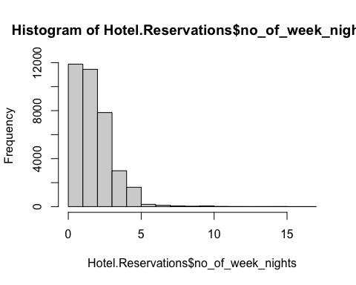

ggplot(Hotel.Reservations) +  
 aes(x =avg_price_per_room , y =lead_time) +  
 geom_point(shape = "square", size = 1.5, colour = "orange") +  
 theme_minimal()



